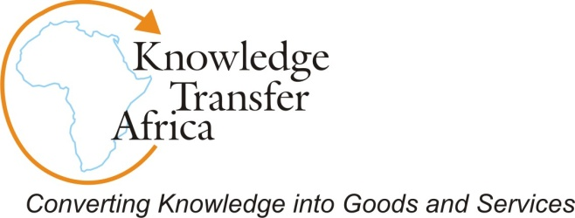

Traducture and Sensemaking: Experiences from Southern Africa
Charles Dhewa
Abstract
Translation improves the way people make sense of the world, leading to better decision making. Experiences in Southern Africa have shown that translation and the related notion of traducture have a significant role to play in development. Our interventions have used sensemaking theory as a torch in exploring translation and traducture with communities and other stakeholders. Sensemaking involves placing stimuli into frames and our work has shown that when people put stimuli into frames they are able to comprehend, understand, explain, attribute, extrapolate, and predict. Frames enable people to locate, perceive, identify, and label occurrences in their lives and world. To a large extent, sensemaking can be viewed as a process in which individuals develop cognitive maps in their environment. Since people develop cognitive maps through their languages, translation has an important role in understanding how people from diverse cultural and linguistic backgrounds make sense of the world. Through translation, the diversity of African languages enriches sensemaking. These languages have vivid words that draw attention to new possibilities through metaphors, idiom, poetry, etc. Access to these varied images enable Africans to engage in more adaptive sensemaking than organizations or cultures with limited vocabularies. This is critical for development practitioners who engage with people based on many assumptions about language and understanding of issues.
Sensemaking and traducture in African communities
In African communities, as elsewhere in the world, sensemaking is about the ways people generate what they interpret and this has a huge bearing on traducture. To engage in sensemaking is to construct, filter, frame, create facticity and render the subjective into something more tangible. Engaging communities through traducture can reveal that sensemaking has the following features: it is grounded in identity construction; retrospective; social; enactive of sensible environments; on going; focused on and extracted by cues; and, driven by plausibility rather than accuracy.
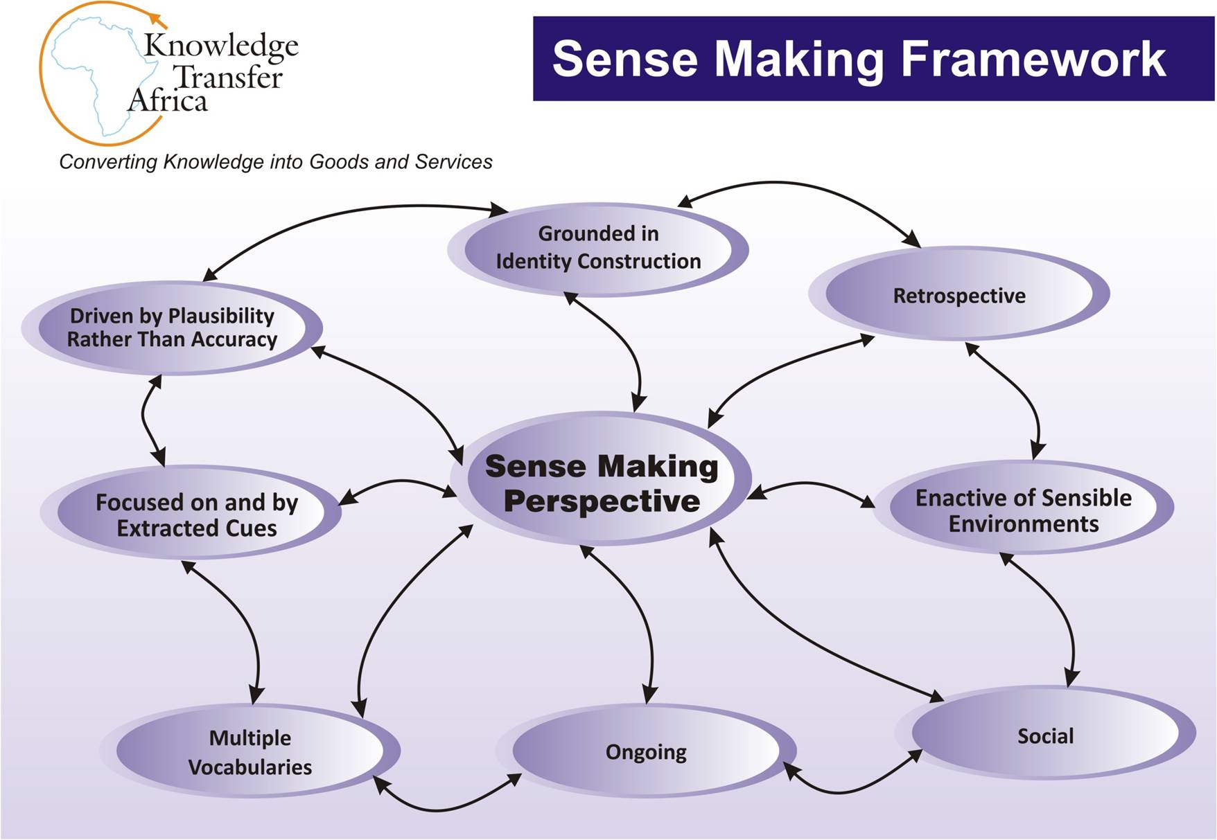
- Grounded in Identity Construction: Sensemaking begins with a self-conscious sensemaker and the need within individuals to have a sense of identity – a general orientation to situations that maintain esteem and consistency of one’s self-conceptions. Through Community Knowledge Centres and use of local languages to generate knowledge through stories, communities have started reviving and appreciating the value of their totems and clan names. Totems and clan names are the basis on which people dig into the history of their families. Family is important because it is the place in which you initially experience all the ingredients of self-belief and identity. There is no crisis in a human being that is bigger than the crisis of loss of identity. In many African communities, families start first with blood relatives, followed by relatives of blood-relatives, who may not be your own blood – relatives. Then we get to in-laws, friends and neighbours and all of these form and bond into clans and, or communities. In Africa, my father’s brother is my father not my uncle. My uncle is my mother’s brother. An understanding of relationships is very important in translation.
- Retrospective: People can know what they are doing only after they have done it. They do so by connecting dots looking backwards. Clarity on values clarifies what is important in elapsed experience, which finally gives some sense of what that elapsed experience means. Translation and use of local languages is helping shape indigenous knowledge into a coherent set of ideas, enabling people to benefit from the wisdom of their ancestors. Communities are now able to retrieve their collective cultural memory and use this as a way forward to development. They have realized that unless they rediscover themselves, their roots and heritage, they will not have the self-confidence to create a new modern African society.
- Enactive of Sensible Environments: People produce part of the environment they face. They receive stimuli as a result of their own activity and find what they expect to find. Growing up in the philosophy of Ubuntu has made many Africans adjust to the fact that you are a human being because of other human beings.
- Social: An individual creates novel thoughts in the context of interactions with others, and then communicates them to the large community. The larger community generalizes these ideas such that they become part of the culture. Through their heritage of Unhu or Ubuntu, African communities have embraced the supremacy of a strong sense of belonging and sense of connectedness with others through various social activities.
- Ongoing: Sensemaking, interpretation and translation builds on sensitivity to various ways in which people chop moments out of continuous flows and extract cues from those moments. For example, smallholder farmers are always in the middle of complex situations which they try to disentangle by making and then revising provisional assumptions. While the world is continuous and dynamic, most development organizations working with farmers keep resorting to absolute categories that ignore large pieces of continuity, thereby entrapping themselves in misconceptions. Traducture can help in getting to the bottom of these dynamics and inform development interventions.
- Focused on and by Extracted Cues: Extracted cues are simple, familiar structures that are seeds from which people develop a larger sense of what may be occurring. Context affects what is extracted as a cue. African languages have a lot of cues on which they rely on for making sense of the world.
- Driven by Plausibility Rather Than Accuracy: Sensemaking is about coherence, reasonableness, creation, invention, and instrumentality. The criterion of accuracy is secondary in sensemaking because people need to distort and filter, to separate signal from noise if they are not to be overwhelmed with data. All this is crucial for translation because what is translated has to make sense. What is necessary in sensemaking is a good story which holds disparate elements together long enough to energize and guide action, plausible enough to allow people to make retrospective sense of whatever happens, and engagingly enough that others will contribute their own inputs in the interest of sensemaking. African stories from the Bantu are good examples of sensemaking templates as shall be demonstrated below.
A thorough grasp on sensemaking processes enhances the impact of translation. In many African communities, people pull threads from several different vocabularies to focus their sensemaking. They pull words from vocabularies of society and make sense using ideology. They pull words from vocabularies of their ancestors and make sense using tradition. They also pull words from vocabularies of sequence and experience and make sense using narratives. This is why stories are an integral part of sensemaking and decision making in Africa.
Significance of Stories as Vocabularies of Sequence and Experience
In Africa, many people think narratively rather than argumentatively or paradigmatically. The importance of this insight is that most models of organization promoted by policy makers, NGOs and development organisations are based on argumentation rather than narration, yet reality is based on narration. This is why communities are often handicapped when they try to make sense of development interventions, because their skills at using narratives for interpretation are not tapped by structures designed for argumentation. Telling stories about remarkable experiences is one of the ways in which people try to make the unexpected expectable, hence manageable. The fact that stories serve as guides to conduct means they facilitate the interpretation of cues turned up by that conduct.
When people put their lives into narrative form, the resulting stories do not duplicate the experience. The experience is filtered. Personal narratives are a product of severe editing because people who build narratives of their own lives use hindsight. The requirements necessary to produce a good narrative provide a plausible frame for sensemaking. Stories gather strands of experience into a plot that produces an outcome. Sequencing is the source of sense and a powerful heuristic for sensemaking. Because the essence of storytelling is sequencing, it is not surprising that stories are powerful stand-alone contents for sensemaking. Stories allow the clarity achieved in one small area to be extended to and imposed on an adjacent area that is less orderly. They enable people to build a database of experience from which they can infer how things work. The following section explores narratives among the Bantu people of Sub Saharan Africa.
Sensemaking and traducture in Bantu oral literature
The Bantu are a linguistic group comprising people who speak over 600 different languages in many African countries, all derived from a common proto-Bantu language. There are more than 250 million speakers of Bantu languages in Africa. In Bantu language, mu-ntu means "a person" or "human being, and its plural is ba-ntu meaning "people" or "human beings". For Africans, the term Bantu, is a reminder of their common history, oneness, and greatness, as a people, the Bantu. U-buntu, in Bantu thought stands for "the best way for a human being to be a human being", the ideal way to be a human being, the ultimate truth, and the end- quest for man.

All the Bantu share a common view or vision of the universe, in addition to sharing the common proto-language. In Bantu thought and cosmovision, all reality, all existence, is NTU, which in English approximately translates as BEING. NTU is constituted by three elements which are nature, man, and spirit. By encountering and comprehending the universe through a Bantu language, and experiencing Bantu-life-styles, all Bantu inculcate in themselves, almost involuntarily, a specific sense of "NTU". This sense of NTU is in the music of the Bantu, in their language, their dance, their drama, their religiosity and their faith. It determines and dominates all their indigenous knowledge systems, all their "sciences", all their ways of negotiating nature and the universe, and all their ways of cognizing reality.

One of the more prominent Bantu indigenous knowledge systems, or “sciences”, is its oral narrative performance system, referred to in contemporary literature as stories and story-telling, or myths and myth-making. In a survey of the oral narratives of the Ndebele, Shona and Tonga Bantu groups in Zimbabwe and Zambia, we found that any member of the community can perform a narrative. Story-telling sessions do not take place on set occasions but spontaneously from informal groups gathered together in leisure in the evenings. Various units of Bantu narratives become, in the performance, symbolic elements in whose relationships, they metaphorically express, and at the same time, constitute UBUNTU.

All participants in any given Bantu narrative performance already know the story being told. However each narrative is a unique experience for all involved. Several factors vary with every performance of a story. These variations are determined by the talent and past experiences of the performer, past experiences and identities of members of the audience, and how participants are related to one another in the real social world. No matter how faithfully a performer tries to stick to the story as they heard it before, they always end up with their own version. Different versions vary in detail and emphasis, and substitute different but equivalent symbols. Thus, while sticking to the basic story as it is known in the tradition, performers can shift emphasis, and cut out details, in order to exploit to the fullest their own performing talent and the composition of their audience.

The Bantu experience each and every narrative within the context of their community’s whole repertory of stories. For them, therefore, the symbolization and metaphorical transformations actually takes place within the context of all the narratives they have experienced in the past. It is therefore easy to imagine the intense and high level of abstraction at play in this context. The following are synopses of three narratives from three different Bantu groups in Southern Africa. The Nsenga, the Shona, and the Xhosa, of Zambia, Zimbabwe and South Africa, respectively. These stories were translated into English from their respective languages.

Narrative 1
Once upon a time there lived an old couple that had no children. They were very miserable because they had to do all the house chores by themselves. They had no one to fetch firewood or water for them. No one came to help them clean their house and wash their dishes. They had to do everything themselves.

One day the goats got together and decided to do all the house chores for this old couple, whilst they were out working in the fields. The goats made sure that they cleaned up the whole place and left no trace of their visit. When the old couple came from working in the fields, they were pleasantly surprised to find that all the house chores had been taken care of. They attributed the good work to the kindness of the people of the village. Little did they know that it was goats, and not people, who were doing the chores for them!

This happened over several days. One day after doing all the work, including brewing beer for the old couple, the goats decided to taste the very beer they had brewed. They drank the beer and found it very sweet. They liked it! They drank and drank, till they were all drunk. The chief goat got so drunk that he decided to climb up to the roof of the house. He started singing and dancing from there. Everyone, including the women, got drunk. They were all singing and dancing. The chief goat defecated there on the roof, and the women goats did the same on the ground, all over the courtyard. The place was a proper mess!

The old couple returned home in the midst of all this chaos. They were shocked to find that it was not people but goats, which had done the house chores for them. They were furious. They were not going to drink beer that had been brewed by goats. They threw away the beer, and chased away the goats. The chief goat came tumbling down the roof in a drunken stupor. All the goats ran away into the forest.

Narrative 2
One day a woman went hoeing in the field. Before she started hoeing she put her baby under the shade of a tree. Whilst she was working in the field some baboons came and stole her baby. When she finished hoeing she looked for her baby everywhere but could not find it. So she had to go home without her baby. She waited for a long time expecting whoever had taken her baby to return it to her, but nobody did. The baboons that had taken the baby decided to look after it. They fed the human baby on their own baboon-food.

Years later the baboons decided to bring back the baby. The woman was very grateful. The woman then lived with her baby who became a fully-grown beautiful girl. The woman however was never happy because her daughter did not like the cooked food she gave her. Instead the girl preferred uncooked food, baboon food! Eventually, the child had to leave. She went and joined the baboons permanently.

Narrative 3
Once upon a time there was a woman who lived with her daughter. The daughter got married and went to live at her husband’s homestead. At one time the girl came to visit her mother. After her visit she traveled back to her husband’s home. On the way she stopped by a river to take a bath. Whilst she was bathing a mbulu (a human-like but hideous creature with a tail) came by and took away her clothes. It insisted that she wore the mbulu’s own dirty rags. The girl did that and the two traveled together to the girl’s in-laws’ home. They lived together at the mother-in-law’s house, with the mbulu insisting that it was the girl and the girl was somebody she had met on the way and decided to bring home as a servant.

The mother-in-law suspected that something was wrong and sent her son to go and tell the girl’s mother what she suspected had happened. The girl’s mother traveled and came to this household. She brought two chickens with her and gave one to each of the “two” girls.
The girl who was her real child boiled some water, plucked the chicken, cut it into pieces, and cooked it. The girl who was in fact the mbulu simply took the chicken, put it into to a pot, whole and unplucked as it was, and cooked it. The two women immediately knew which one of the two was the real human girl. They chased away the mbulu.

Any non-Bantu person reading or even listening to these stories and seeking to interpret them could give them various “meanings”. The first narrative could, on the surface of it, be said to be cautioning people against taking “windfalls” for granted, because they could turn out to be something quite different from what they seemed at first. The old childless couple thought that someone in the village had taken pity on them and decided to help them, only to find that it was not people but goats helping them. Some interpreters might even hazard that it is all to do with the relationship between the Bantu and their goats.

The Shona narrative about the baboons could be taken as a warning to mothers about where they leave their children. They risk losing them to wild animals if they do not take enough care. The Xhosa story could be said to be about the dangers that lurk in the bush and the inadvisability of young solitary girls stripping and taking a river-bath in the middle of nowhere.

All these would, at various levels, be seen as plausible “explanations” or “interpretations” of the stories. However the stories have much greater and substantive import within the narrative system, but even more so within the Bantu tradition as a thought. This is at the level where the surface event images all transform into, and function as, symbolic units, within specific logical structures. In fact the three narratives are equivalents within the Bantu narrative system. They all share the same logical structure. Their ultimate impact or affectivity on the Bantu participants is identical.

For the Bantu, all the above narratives address a deep philosophical question of human nature. What is it that distinguishes humans from non human beings? And one of the answers provided by the narrative system is that it is culture and cultured behaviour that distinguishes humans from non-humans. This “truth” is thereby hammered home into the psyche of all Bantu from a tender age. It is a truth they affectively inculcate into themselves without having to go to school to “learn” it.

In the second and third event-images of the first narrative the goats behave in a cultured way. So when these beings, the goats, behave in a cultured way people see them as human. Their humanity is in their behaviour. As long as they behave in a certain way there is no problem with their assumed humanity. However as soon as these “kind-hearted” people behave in an unspeakably uncultured manner, they are immediately recognized as non-humans. The goats are no longer merely goats but symbolic elements. Their non-human beingness, indeed the goatiness, is not simply in their being four-legged animals, it is in their actions, their lack of culture. The chief goat sits on top of the roof and sings drunkenly. The other goats dance and defecate all over the courtyard. Even the “women” also do the same right there.

The same point about culture being the defining feature of human beings is also made in the narrative about the girl brought up by baboons. For all her human physical features, the fact that she could only appreciate uncooked food, was not cultured, immediately made her “non-human”, as physically human as she was. So she had to go and live permanently with the baboons.

We see three different narratives from three different Bantu language groups, with totally different event-images sharing the same structure and having equivalent symbols. The diversity of materials that go into the narratives of this group illustrates the fact that the narratives embody certain cardinal ideas of Bantu thought, rules and laws. Through the narrative performance system, the Bantu come to appreciate and “know” nature and the universe in a way that cannot be expressed through ordinary language. There arises from the structures and the symbols together with a whole host of transformational processes, a new language which requires translation and traducture for other people to understand.

At the foundation and core of this language are the notions of “structure”, “symbol” and “metaphor”, all greatly akin to those to be found in the language of the laws of the physical sciences and in abstract mathematical structures. The difference between the two is that the construction of the literary structures and symbolization processes bear a certain subjective, emotional, if not spiritual quality, which is totally lacking in the construction of mathematical structures. Thus there is a teleological dimension to indigenous knowledge systems and epistemologies (and associated pedagogies) that cannot be found in the conventional physical sciences.
At the epistemological level, a greater understanding of Bantu indigenous knowledge systems, as exemplified by the Bantu oral narrative system, would contribute to the new paradigm unifying all sciences and demonstrating the ultimate meaningfulness of the universe. This is where translation becomes very important in promoting multi-disciplinary and inter-disciplinary collaborative research.

Another critical issue from the above narratives is that in Bantu mythology there is no separation between animals and people. In fact, animals can house a human spirit and vice – versa: a human can host an animal spirit. It is not surprising therefore, that the bulk of the totems and clan names in Africa are based on animals. In Bantu folklore, human beings, trees and animals are closely inter-related to the extent that animals and people speak the same language. There are many stories around how human beings have a lot to learn from animals in all spheres of life, from power, politics, human relations, but above all character and behaviour. Traducture has an important role in surfacing the power of this folklore for the benefit of all humanity. Understanding and translating the language spoken by animals and trees requires a certain skill which is embedded in Ubuntu.

Another emerging role for traducture

Traducture can be a viable model in reclaiming African education systems. Millions of youth who at home speak African languages and learn many social skills through their mother tongues, leave this knowledge behind to go to school where they learn a completely new way of life. Right from pre-school, African children are faced with a major clash between what they see, hear and learn at home and what they see, hear and learn at school. Although some of the knowledge acquired at school is very helpful, the ongoing tension between the two forms of knowledge (indigenous and western) creates conflict. Instead of learning that they should select the best from both worlds and build on their own culture, youth are taught that African indigenous culture is ‘backward’ and that only the Western way of life is useful. Traditional and indigenous knowledge has been relegated to an inferior position compared to Western forms of knowledge. Both Africans and non-Africans tend to assume that if knowledge has not been written in a Western-style book, or if knowledge is not taught in a formal school, college or university, therefore it is not knowledge at all.

Domesticating science and technology is another role for traducture. At the moment, educated Africans can only connect with their relatives using African languages at a limited level. If they want to delve deeper into conversations about technology, they cannot connect with everyone else through mother tongues. Because technology is very important in the modern world, languages in which people talk about this technology is the medium of power. In Africa, as in the majority of countries across the world, English – the language of Western capitalism – is really the language of power. The majority of people who cannot command English have no space in science and technology. Translation/traducture should help Africans add cultural value to technological knowledge so that it can be interpreted through African languages.

While African culture is very dynamic, over the years, it has lost some of its dynamism because it was swept aside as being an inferior knowledge system. As a result it is not used in the running of modern states. However, it is still used in a limited sense in rural and other urban settings, where Africans realise that it is the only source of knowledge that they have in order to function. For example traditional medical knowledge. Africans’capacity to borrow knowledge from others intelligently has also been greatly reduced. One needs to have confidence, self-belief, and a dynamic culture and society in order to selectively and intelligently borrow knowledge from elsewhere, then bring it home and make it suitable and relevant to one’s people and society. Traducture is important for this to happen.

KTA is working with communities in assisting them to solve their problems through gathering and writing up African sources of knowledge, wisdom and stories, as well as folklore in local languages. African communities should be encouraged to leverage their knowledge based on the solid foundation of Ubuntu, which our ancestors crafted over centuries. They also have to aggressively and intelligently borrow technological knowledge and translate it into local languages for the purpose of education. It is through African stories, folklore, mythology, praise poetry, proverbs and art, among many other ways, that the world can tap into the wealth of African wisdom. Africans should understand that being modern is not a question of sacrificing the past in favor of the new, but of maintaining, comparing, and remembering values created by their ancestors, making them modern so as not to lose the value of the modern. Should we sacrifice the past in favor of the new? Traducture can be one of the suitable conceptual frameworks for achieving all these ambitions.
Charles Dhewa is the Director of Knowledge Transfer Africa Trust (KTA), an organization based in Harare Zimbabwe. He can be contacted through: dhewac@yahoo.co.uk / charlesdhewa7@gmail.com.

References
- Weick, K, (1995) Sensemaking in Organizations, SAGE Publications.
- Mansuetto A, “Cosmic Teleology and the Crisis of the Sciences”, Philosophy
of Science www.bu.edu/wcp/Papers/ScieMans.htm.1999-30-10 p1
3.Emeagwali G, Äfrican Indigenous Knowledge Systems (AIK): Implications
for the Curriculum” www.multiworld.org/m-versity/articles/gloria1.htm p1.
- Shutte A 2001 UBUNTU An Ethic for a New South Africa, Pietermaritzburg
South Africa, Cluster Publications.
- Maranda P, (1972) Mythology: Selected Readings, Baltimore, Penguin Books p8.
- A few words on translation - www.your-translations.com
- African science must tackle local language barriers:
http://www.scidev.net/en/opinions/african-science-must-tackle-local-language- barriers.html
- African Science Speaks Many Languageshttp://www.new- g.info/focus/focusItem.php?a=1836
9. Mandivamba, R, (2007) Being Afrikan: Rediscovering the Traditional Unhu-Ubuntu-Botho Pathways of Being Human, Mandala Publishers.

